Mesilla Valley Audubon Society (MVAS)
Bird Monitoring and Conservation Project Protocol
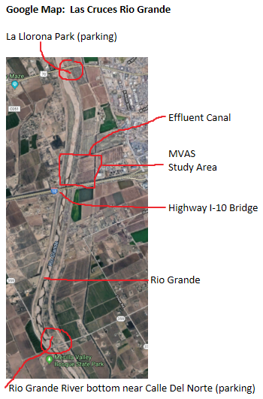
This MVAS project is designed to document the impact of the planned creation of a new riparian habitat on the Rio Grande as it passes through Las Cruces. Currently the city delivers eight million gallons of treated wastewater daily to the Rio Grande directly via a cement canal and all the surrounding land is barren.

By the end of 2020 multiple governmental agencies including the US International Water Boundary Commission, the City of Las Cruces, and others will replace the canal with a meandering stream with ponds, surrounding willows and other native flora, and attract birds 12 months a year. By measuring the bird population before and after completion of the work, MVAS is providing important data that will help guide future interventions on this section of the Rio Grande and elsewhere. Not only will our work help with local knowledge of the Rio Grande environment, it will also help place our situation in perspective compared to the rest of the Southwest.

This protocol provides all interested birders instructions on how to collect and report data using guidelines created by the National Audubon Society for its Western Rivers Bird Count. Anyone is welcome to participate in the project. This page is meant to be self-explanatory, but if questions arise, call Sid Webb (MVAS member) via phone(575-915 5017) or email (sidwebb@gmail.com).

Observing Protocol
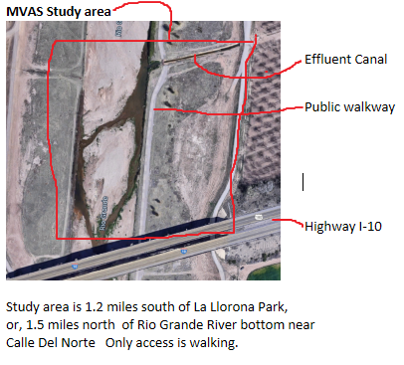
Location for study: Along the Rio Grande between the bridge over I-10 and the water effluent canal. (See maps on this page). eBird.com has designated this area as eBird.org Hotspot: Rio Grande- Las Cruces: Treatment Water Canal South to I-10 (control-click for web page)
Follow data collection protocol outlined on Audubon’s Western Rivers Bird Count (page 2)
1, MVAS Study Area: Rio Grande- Las Cruces: Treatment Water Canal South to I-10
2. Report all species seen with special attention to the 4 birds designated by Audubon (for comparison purposes)
3. Monitor 12 months per year.
4. In eBird.com, when entering data, under comments section add “MVAS project”
5. Submit your list to ebird.com.
6. Send a saved copy of your list to Mark Pendleton (mpndltn@gmail.com).

Page 1 version 11/7/2019 Sid Webb

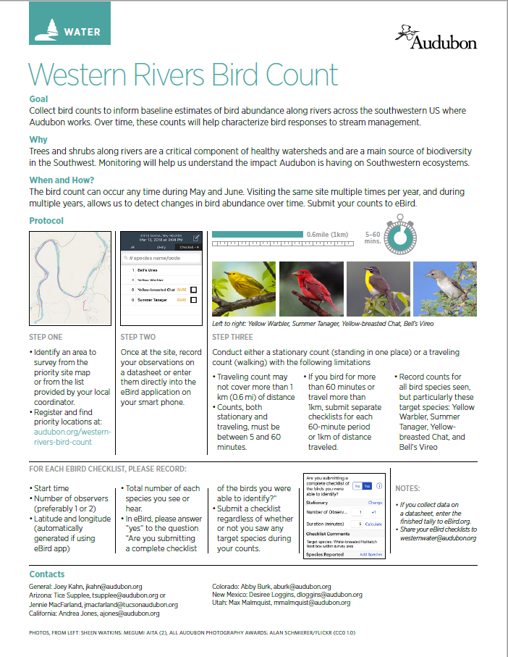
More information: MVAS Project: https://www.mvasaudubon.org/ . Audubon Western Rivers Bird Count: https://www.audubon.org/western-rivers-bird-count Page 2

